EDA for Blackwell Electronics

Data was analyzed at the request of Blackwell Electronics for 4 stores and 80,000 transactions.

Blackwell was interested in determining if there was a relationship between the amount spent and the region of purchase, as well as if there is a relationship between the amount spent and the number of items purchased.

The charts below shows the average spent per purchase for the 4 regions. We can see clearly that region 4 has the greatest average spent per transaction. Region 2 has the least amount spent per transaction.

region

1 744.990939

2 252.097741

3 917.969637

4 1283.938357

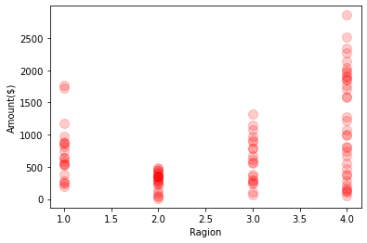

Conversely, when trying to answer the question of whether or not there is a correlation between total items purchased and amount spent we can see according to the correlation map below, there is only a very slight correlation between them.

in-store age items amount region

in-store 1.000000 -0.178180 -0.003897 -0.085573 -0.133171

age -0.178180 1.000000 0.000657 -0.282033 -0.235370

items -0.003897 0.000657 1.000000 0.000384 -0.001904

amount -0.085573 -0.282033 0.000384 1.000000 0.403486

region -0.133171 -0.235370 -0.001904 0.403486 1.000000